Architectural Wood Casework
Kitchen & Pantry:
Omega Dynasty cabinets inset construction with solid reversed raised panel painted maple doors.

Door profile options (please choose one):
Milena
Benson
Woodward

Color:

Upper cabinet height: Standard 36” Upgrade: (39” up to 48”):

Specify Powder 1: Omega Dynasty full access cabinet overlay door.

Door profile options (please choose one):
Benson
Woodward

Color:

Specify Master Bath 1st Floor: Omega Dynasty full access cabinet with overlay door.

Door profile options:
Benson
Woodward

Color:

Specify Bedroom 1 (2nd Floor):

Door profile options:

Benson
Woodward

Color:

Specify Bath 2: Omega Dynasty full access cabinet with overlay door.

Door profile options:

Benson
Woodward

Color:

43 00 - Wood Stairs and Railings

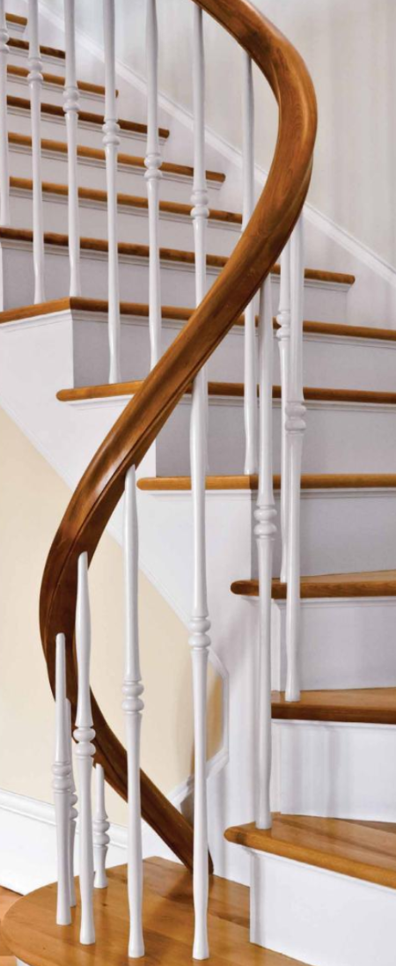

Handrail stain color:
Balusters:
Fitts F5040 Lexington
Stained? Painted?
Baluster stain or paint brand & color:

07 24 00 - Exterior Insulation and Finish Systems

Window Trim Paint Color:

White
Off-white
Other

If “other,” please specify manufacturer and color:

Soffit Trim Paint Color:

White
Off-white
Other

If “other,” please specify manufacturer and color:

Exterior trim color (manufacturer and color name):

Exterior siding color: (manufacturer and color name):

07 31 13 - Asphalt Roof Shingles (CertainTeed Landmark AR 30 Yr.)

Color (sample board will provided at design mtg):
Copper flashings, copper gutters? Yes No (additional costs apply; market price)

07 46 00 - Siding

Provide and install siding exterior in accordance with applicable building codes and manufacturers guidelines.

Wood Siding

Please choose one:
Standard: 18” R&R Red cedar shingles – second floor, gables, dormers areas, and apered cedar clapboard ½” x 6” – first floor areas:
Shingle entire house:
Clapboard entire house:

07 60 00 - Flashing and Sheet Metal

Copper flashing at exposed roof and siding details desired? Available upon request at additional cost. Yes No

07 71 23 - Manufactured Gutters and Downspouts

Copper flashing at exposed roof and siding details desired? Available upon request at additional cost. Yes No

08 11 01 - Exterior Doors

Front Door
Painted finish

Stain finish

Color of paint or stain:

Great Room exterior door paint color:

Sun Room exterior door paint color:

Mudroom exterior door paint color:

Kitchen exterior door paint color

Metal or wood combination screen and storm doors are available upon request for additional cost at exterior door locations.

Please indicate if screen and/or storm doors are requested at any locations:
Front: Screen Storm Both
Great room: Screen Storm Both
Sun room: Screen Storm Both
Mud room: Screen Storm Both
Kitchen: Screen Storm Both

Window Options:
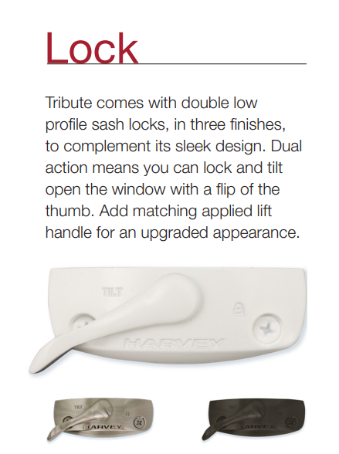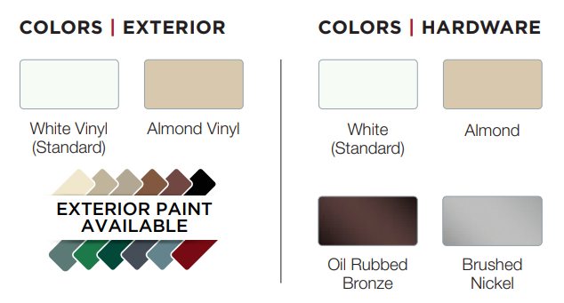

Specify lock hardware finish choice:

Exterior:

Hardware:

08 71 00 - Door Hardware

Mfg & Model INTERIOR:

Emtek Georgetown

Emtek Norwich

Additional Emtek selections are available upon request; would you like to consider other options?

Yes
No

Mfg & Model EXTERIOR:

Emtek Willshire keyed entry sets.

Choose finish:

Brushed nickel

Polished brass

Chrome

Oil-rubbed bronze

08 71 01 - Door Hardware - Thresholds
Anodized aluminum thresholds come standard. Would you like to consider OAK thresholds for select exterior doors? (Additional cost applied)

Yes
No

09 72 01 - Door Hardware – Cabinets
*Please note all product photos included in this document are intended to be representative. The products that are eventually installed might be slightly different. Significant differences will be discussed with Buyer prior to ordering and installing.

KITCHEN
PANTRY
cabinet knobs
A | 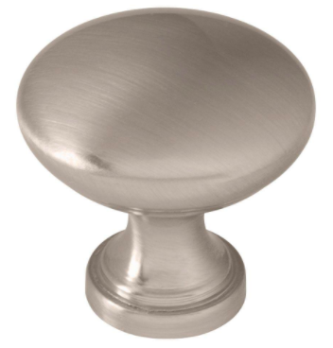 | 1-1/4" "classic" round satin nickel knobs
B | 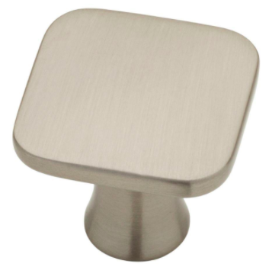 | 1-3/16" square satin nickel knobs (+$)
C | 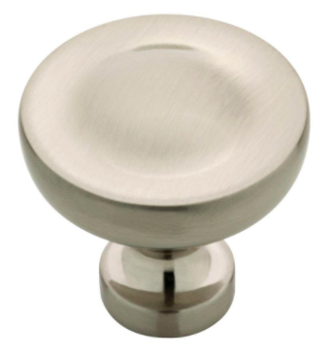 | 1-1/4 round satin nickel knobs (+$)
drawer pulls
A | 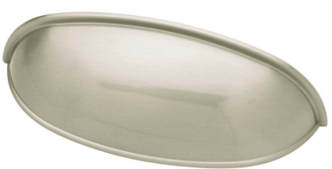 | 3" satin nickel "cup" drawer pulls
B | 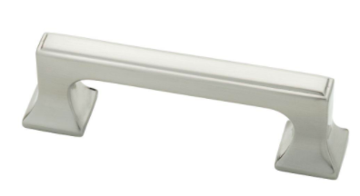 | 3" satin nickel "square" drawer pulls (+$)
C | 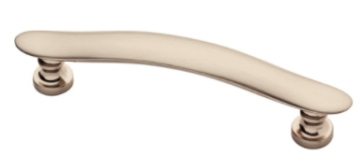 | 3.75" "satin nickel bell" drawer pulls (+$)
MASTER BATH 1 & 2
cabinet knobs
A | 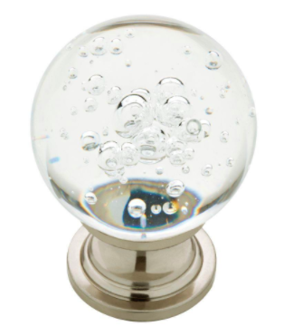 | 1-3/5" round clear bubble glass knobs with satin nickel base
B | 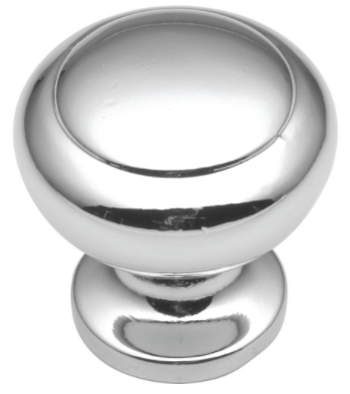 | 1-1/4" round polished chrome cabinet knob
C | 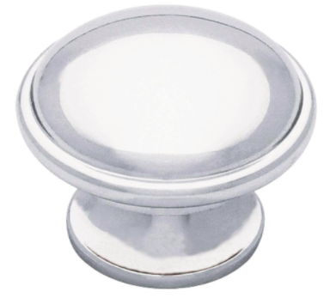 | 1-1/2" round polished chrome cabinet knob
drawer pulls
A |  | 1-3/5" round clear bubble glass knobs with satin nickel base (used for doors and drawers)
B | 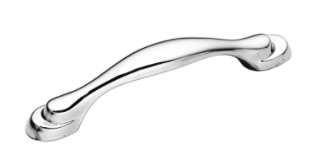 | 3" polished chrome drawer pull
C | 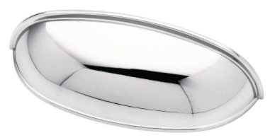 | 2.5" polished chrome "cup" drawer pull
GUEST BATH
cabinet knobs
A | 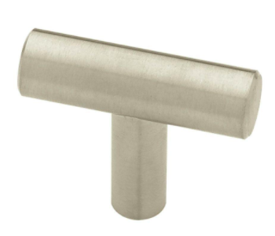 | 1-9/16" stainless steel round bar knob
B | 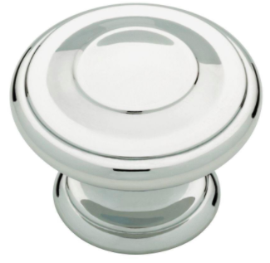 | 1-3/8" polished chrome round knob
drawer pulls
A | 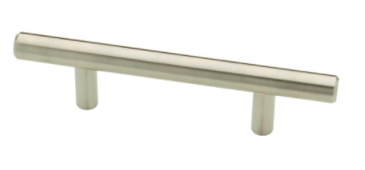 | 3" stainless steel round bar pull
B | 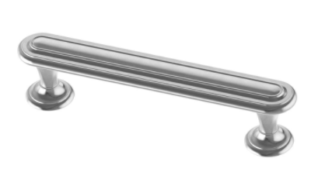 | 3-3/4" polished chrome pull
1/2 BATHS
cabinet hardware (choose pull or knob for cabinet doors)
pull | 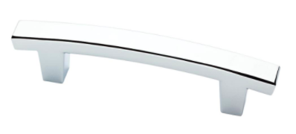 | 3" polished chrome cabinet pull
knob | 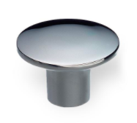 | 1-1/4" round polished chrome cabinet knob

08 75 00 - Window Hardware

Finish:

Brushed nickel,

Polished brass

Chrome

White

83 00 - Mirrors

Upgrade to Kohler K-CB-CLR1620FS medicine cabinets (additional cost may apply; standard mirrors credited toward purchase)

Upgrade to Roburn medicine cabinets (additional cost may apply; standard mirrors credited toward purchase)

09 30 00 - Tiling

Mudroom Tile:
Tile color, size, and style varieties presented by GC during design meeting prior to material order

Mudroom tile decision:

Mudroom Grout (Laticrete)

Color palette will be available through Builder during design meeting.

Mudroom grout color:

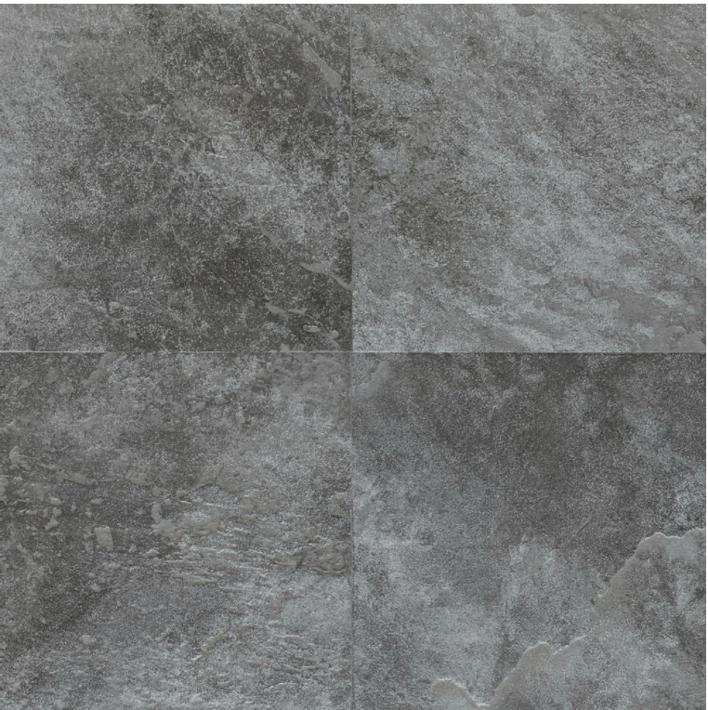

Laundry Room Tile:
Tile color, size, and style varieties presented by GC during design meeting prior to material order

Laundry room tile decision:

Laundry Room Grout (Laticrete)

Color palette will be available through Builder during design meeting.

Laundry room grout color:

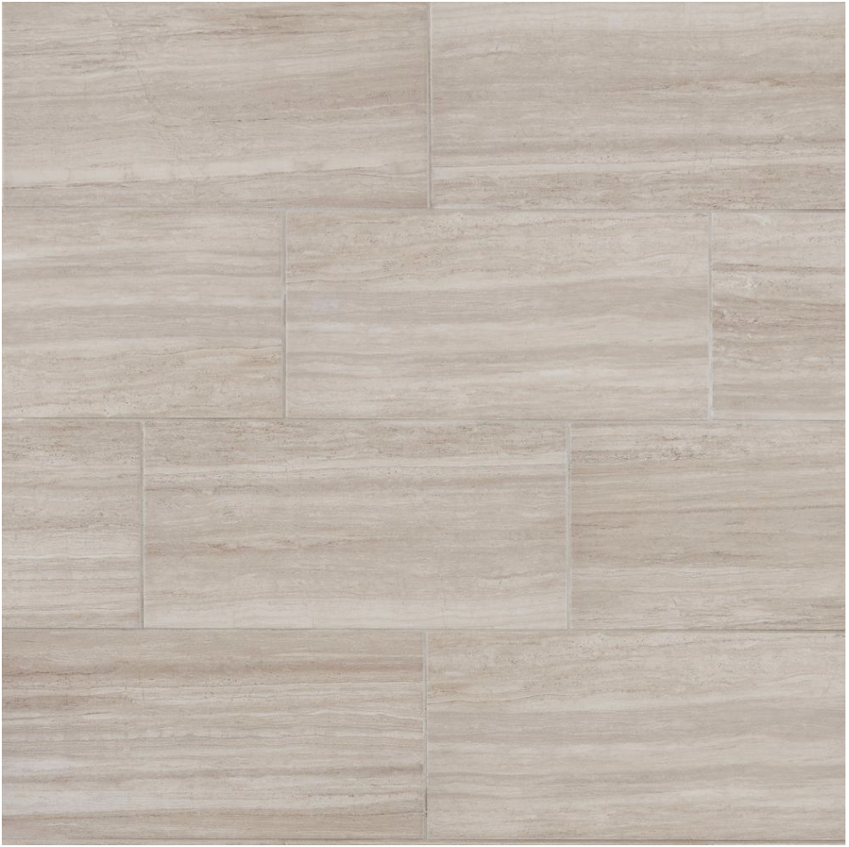

Master Bathroom Tile:
Tile: Daltile Calacatta Marvel Matte or other (Color, size, and style varieties presented by GC during design meeting prior to material order)

Master bathroom tile decision:

Master bathroom grout: Laticrete.

Color palette available through Builder during design meeting

Master bathroom grout color:

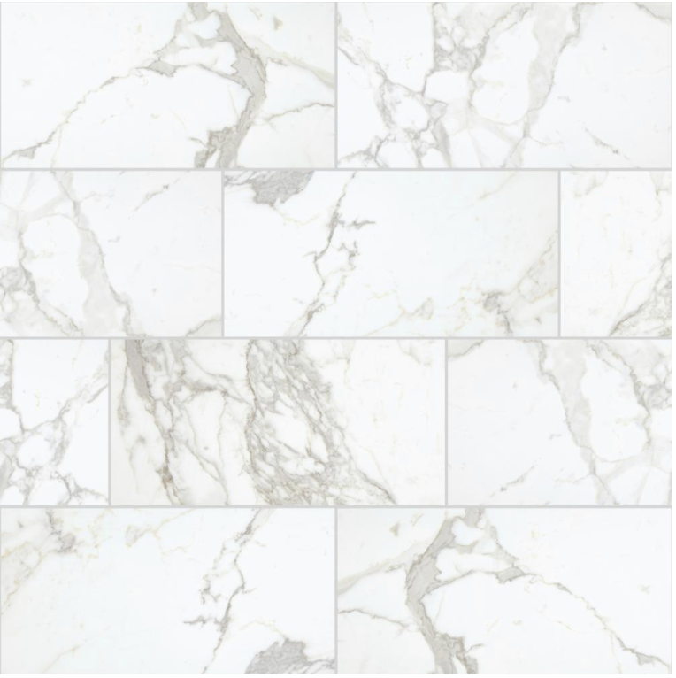

Master Bath Shower: Floors shall be installed with a 12”x12” gray marble mosaic.
Underlayment: Schluter Systems Ditra

Master Bathroom Shower Tile:
Tile: Daltile Restore Mist or other (Color, size, and style varieties presented by GC during design meeting prior to material order)

Master bathroom shower tile decision:

Master bathroom shower grout: Laticrete.

Color palette available through Builder during design meeting

Master bathroom shower grout color:

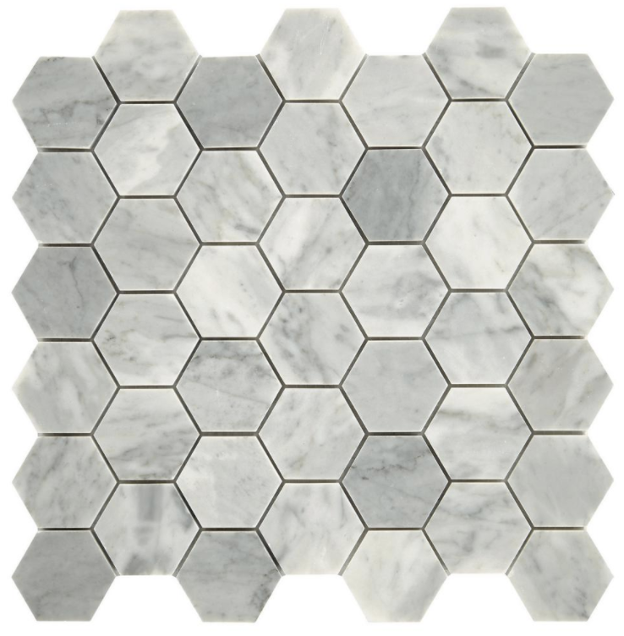

Bath 1:
Tile: Daltile Restore Mist or other (Color, size, and style varieties presented by GC during design meeting prior to material order)

Bath 1 Tile:
Tile color, size, and style varieties presented by GC during design meeting prior to material order

Bath 1 tile decision:

Bath 1 Grout (Laticrete)

Color palette will be available through Builder during design meeting.

Bath 1 grout color:



Bath 1 Shower:
Tile: Daltile Hamilton or other (Color, size, and style varieties presented by GC during design meeting prior to material order)
Bath 1 Shower Tile:
Tile color, size, and style varieties presented by GC during design meeting prior to material order

Bath 1 Shower tile decision:

Bath 1 Shower Tile Grout (Laticrete)

Color palette will be available through Builder during design meeting.

Bath 1 shower tile grout color:

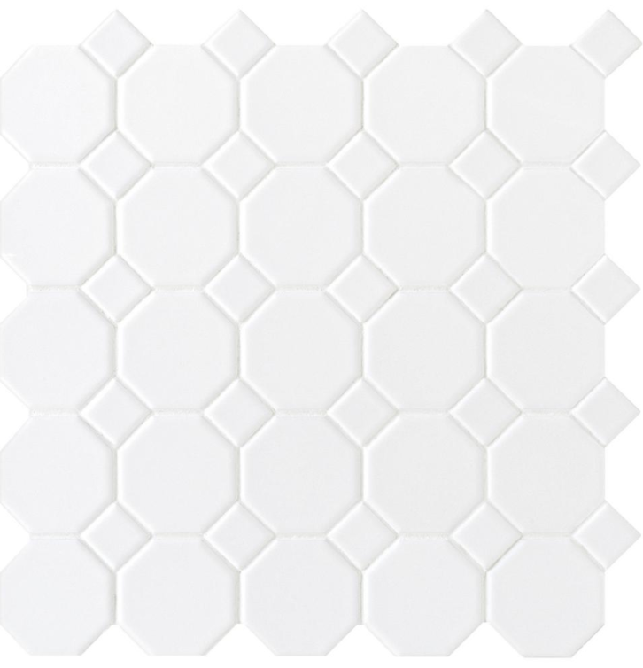

Bath 2:
Tile: Daltile Restore Mist or other (Color, size, and style varieties presented by GC during design meeting prior to material order)

Bath 2 Tile:
Tile color, size, and style varieties presented by GC during design meeting prior to material order

Bath 2 tile decision:

Bath 2 Grout (Laticrete)

Color palette will be available through Builder during design meeting.

Bath 2 grout color:

Grout: Laticrete. (Color palette available through Builder during design meeting.)

Bath 2 Shower: Floors shall be installed with a 12”x12” matte black and white mosaic porcelain tile.
Underlayment: Schluter Systems Ditra
Tile: Daltile or other (Color, size, and style varieties presented by GC during design meeting prior to material order)

Bath 2 Shower tile decision:

Bath 2 Shower Tile Grout (Laticrete)

Color palette will be available through Builder during design meeting.

Bath 1 shower tile grout color:

Walls:

Master Bath Shower:

Tile: Daltile or other (Color, size, and style varieties presented by GC during design meeting prior to material order)

Master Bath Shower tile decision:

Master Bath shower walls grout:

Bath 1 Shower:

Tile: Daltile Hamilton or other (Color, size, and style varieties presented by GC during design meeting prior to material order)

Bath 1 shower tile decision:

Grout: Laticrete (Color palette available through Builder during design meeting.)

Bath 1 shower walls grout:

Bath 2 Shower: Shower walls shall be installed with
3”x9” porcelain subway tile, to the height of 6' high above floor.

Tile: 3”x9” subway (Color, size, and style varieties presented by GC during design meeting prior to material order)

Bath 2 shower walls decision:

Grout: Laticrete (Color palette available through Builder during design meeting.)

Bath 2 shower walls groud:

Misc. Areas:

Hearth & Surround Great Room

Hearth & surround great room tile decision:

Kitchen Backsplash:

Kitchen backsplash tile decision:

Sunroom:

Sunroom tile decision

09 64 00 - Wood Flooring

Hardwood surface color/finish:
Natural clear coat included
Stain (can be added for additional cost)? Yes No
If yes, specify stain color (manufacturer and color):
Finish:
satin
semi-gloss.
Size: 3-1/4" to 4”-5” white oak.
Other hardwood flooring species and finish samples available upon request. Additional charges may apply.

Hardwood decision:

09 68 00 - Carpeting

Bedroom 3 Carpet: Home Decorators Collection

Color:

